From:
Note: Stockman's work was received via a paid subscription. Reprinting of properly attributed copyrighted material for the purpose of comment, parody, or criticism is “fair use” and is not copyright infringement.

Fake Bids, Fake Bonds, Fake Boom
By David Stockman. Posted On Wednesday, August 7th, 2019
Gary Kaltbaum hit the nail on the head this AM. We are now talking about incendiary greed. The blow off stage of a blind mania in the bond markets.
After last night's panic bond-buying, there is now $15 trillion of negative yielding bonds on the world market including the 10-year German bond at negative 0.60%. That means for the privilege of loaning $100 to Angela Merkel & Co., you get $94 back ten years later. And you get to eat the interim inflation, too!
Even the 10-year UST touched a low of 1.59% this AM and that's below any so-called "muted" inflation rate you care to pick off the Bloomberg terminal. But we'll stick with the year/year core CPI, which was up 2.14% in June or even the run-rate during Q2 of the Fed's beloved core PCE deflator, which was up 2.3% at an annualized rate.
So after inflation and taxes, everywhere in the world bond-buyers are getting creamed on current yield like no other time in history. None. Not in the last 6000 years.
So why have the bond fund managers of the world become a pack of lemmings?
As Gary says, it's price, price, price.
The fools who are supposed to be investing for safety and yield are chasing the ever rising premium prices of fixed income securities which always and everywhere by their very own terms will revert back to par on maturity.
So this is either a break-out of suicidal impulses in the bond pits or it's the ultimate case of the Greater Fool theory. Yet when the time comes to unload these trillions of massively over-priced and way-above-par bonds, whence cometh the bid?
The most asked question is how can people continue to buy bonds around the globe that are yielding negative. IT IS SIMPLE. Greed! Forget the yields for a second. BOND PRICES have been skyrocketing. Why do you think people have bought a fake meat company stock with $200 million of sales with nothing but losses with a $14 billion market cap?
Greed. It was moving higher. The hope was just sell to someone else. Screw valuations. That is what you are seeing in worldwide bonds. When it turns and greed turns to fear, we cannot imagine what happens in bond markets.
There is potential for all hell breaking loose as this is becoming the most one-sided leveraged trade in history. There will eventually be gigantic, gargantuan, out of this world losses in world bond markets when this greatest of central bank-induced bubbles ends. We just do not know when it ends but we must tell you it feels like the climactic stage is at hand.
The investment grade bond universe is about $60 trillion on a global basis, and there is another $190 trillion of bank debt, commercial paper, private loans, junk bonds and myriad other forms of indebtedness that one way or another are priced off the benchmark sovereign issues in the bond market.
Just let prices fall 2%, 5% or 10% from the insane levels embedded in the subzero universe which sits atop this massive pile of planetary debt and you are talking about trillions upon trillions of losses. That's because when the reckoning finally comes, the sell-off will way over-shoot to the downside---just as it did during the subprime and investment grade mortgage meltdown a decade ago.
Why? Because the global bond markets on the margin are sitting on a sea of hot money leverage. The fast money crowd is using repo and its derivative equivalents to chase anything that is going up, and especially anything that the central banks have been buying or are expected to be buying in the periods just ahead.
This is front-running of biblical proportions. It's a Titanic full of bond managers all stacked up on the starboard side railings leaning over the sides; it will not even require an unexpected iceberg to send the ship rolling into the drink.
Last time around it was the $1.5 trillion subprime market and even the $10 trillion total mortgage market (and most of the latter was GSE guaranteed) that went into meltdown. But after 10-years of lunatic financial repression and upwards of $15 trillion of central bank bond purchases with fiat credits snatched from thin air since 2007, nearly the entire fixed income market has been infected with bubble contagion.
Yet most of Wall Street remains only mildly curious, while Washington has descended into deep oblivion. Not even a handful of our so-called policy-makers and elected leaders recognize that the long-run carry cost of Uncle Sam's $22 trillion of debt---which will be $42 trillion before the next decade is out---is dramatically understated when every single Treasury security (save for the 30-year bond) was trading under 2.0% earlier today, and below the running inflation rate.
That is to say, not only is the entire German yield curve trading at negative nominal yields, but the far, far larger and more consequential U.S. government Debtberg is now trading below zero in real terms.
As George H.W. Bush said in another context: This shall not stand!
Nevertheless, a brief dialogue on the subzero matter that we caught on bubblevision this AM tells you all you need to know. Poor David Faber, who has somehow retained a modicum of financial sanity over all these years on CNBC, couldn't stop fretting about the $15 trillion of negative yielders and the very idea of handing Angela Merkel $100 in order to get $94 back in ten years time.
Never fear, said Jim Cramer, who is obviously the very voice of Wall Street's bullish brain freeze. Just back up the truck and buy some 6% yielding AT&T stock because it's just going to get better and better.
That is, AT&T has a staggering $170 billion of debt, but with the entire world bond market heading to subzero land, it will soon have opportunity to refi at next to nothing, thereby bringing its current $8.5 billion annual interest bill down sharply and causing its $17.4 billion of earnings to soar commensurately.
So you are going to get a big earnings and share price pop and get paid 6% to wait. What's not to like?
That's right. When capital becomes virtually free, one and all down in the casino will become unspeakably rich, or not.
We'll take the "not" side. We'll note that the current madness in the global bond markets is planting financial time bombs throughout the warp and woof of the entire financial system and corporate economy----even the mighty AT&T.
As shown in the chart below, the company's long-term debt has soared by 6.7X or nearly $150 billion since March 2000 compared to just a $24 billion gain in operating free cash flow. Yet why did it issue all that extra debt when its ample, utility-based cash flow was so ample---some $250 billion of free cash flow since the turn of the century?
The answer, of course, is because it could and because the debt was so sub-economically cheap that financial engineering became a way of life. Indeed, during the entire 19 years of this century, the company's net PP&E has risen by only $107 billion---from $47 million in March 2000 to $154.7 billion at present.
The rest of its [AT&T's] prodigious cash flow and borrowings (upwards of $400 billion combined) went into massive M&A deals including Time Warner and prodigious stock buybacks and dividends.
For instance, during the same period that its net PP&E grew modestly, it's goodwill and intangibles (owing to overpriced M&A deals) soared from $11 billion at the turn of the century to $307 billion in its most recent quarter; and it paid out more than $250 billion in dividends and stock buybacks during that 19-year span, as well.
In short, Cramer's vision of virtually zero cost debt, fat dividends and soaring stock price appreciation is testimony to the mania of the moment; and who knows, the fools running the world central banks may yet drive things in that direction for a few more months or quarters.
But at the end of the day, AT&T is a poster boy for the unspeakable ills of monetary central planning and the systematic repression and falsification of financial asset prices which it entails.
Whatever miracles of telecom progress and technological advancement which may be embedded in AT&T huge asset base and service capacity could have been more than funded by the rate-payers ,who generated the company's $250 billion of free cash flow over the past two decades.
Its current towering stack of debt, in fact, was recycled entirely back into Wall Street. It was the financial engineering fuel that helped blow the greatest bubble in history, but did not expand the main street economy hardly at all.
What will come eventually is the very opposite of the Cramerian fantasy that, believe it or not, is driving massive funds into debt heavy big cap stocks on the notion that earnings are going to soar because debt capital is heading for free.
No, not at all. The $15.6 trillion of debt on American businesses---corporate and noncorporate---is a time bomb waiting to explode, and to take earnings, share prices and financial stability into the drink down below.
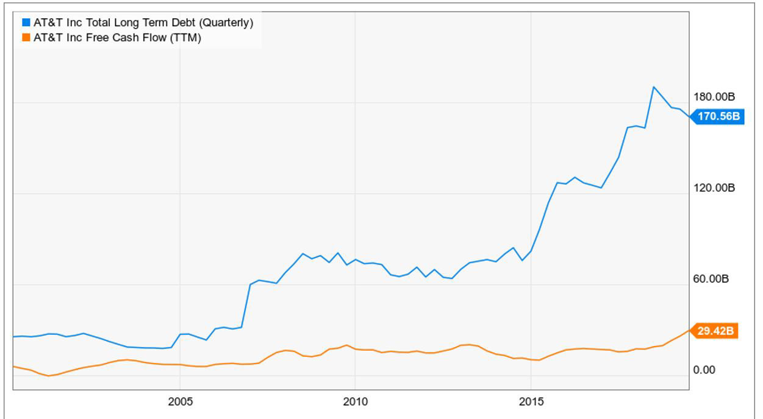
Then again, the boys and girls and robo-machines still hanging around the casino are not alone in this clueless embrace of free money---and we are not talking about AOC (Rep. Alexandria Ocasio-Cortez) and her Green New Deal posse of leftwing zealots.
We are talking about the Orange Swan in the Oval Office, who now appears bound and determined to attack the Fed with relentless Twitter-Fire until it finally does succumbs to that very idea: Namely, that interest rates should be tantamount to zero, and that it is the job of the Fed to follow the even great fools in charge of the world's major central banks into a calamitous race to the bottom:
“Three more Central Banks cut rates.” Our problem is not China - We are stronger than ever, money is pouring into the U.S. while China is losing companies by the thousands to other countries, and their currency is under siege - Our problem is a Federal Reserve that is too.........proud to admit their mistake of acting too fast and tightening too much (and that I was right!).
They must Cut Rates bigger and faster, and stop their ridiculous quantitative tightening NOW. Yield curve is at too wide a margin, and no inflation! Incompetence is a.........terrible thing to watch, especially when things could be taken care of so easily. We will WIN anyway, but it would be much easier if the Fed understood, which they don’t, that we are competing against other countries, all of whom want to do well at our expense!
So there you have it. The day started with $15 trillion of subzero debt and the above incoherent blather from the Donald's Twitter account, yet by the end of the day they had bought the dip back to the green (on the S&P 500).
Still, when this insane house of cards collapses for the third time this century, there will be no mercy for the lemmings---- and most especially those scampering toward the bond pits.
And they will deserve none---even as their bitches in the Eccles Building are finally tarred and feathered and run out of town.

